AQA DOUBLE AWARD GCSE PHYSICS

Resultant forces
A stationary object remains stationary if the sum of the forces acting upon it - resultant force - is zero. A moving object with a zero resultant force keeps moving at the same speed and in the same direction.
If the resultant force acting on an object is not zero, a stationary object begins to accelerate in the same direction as the force. A moving object speeds up, slows down or changes direction.
Acceleration depends on the force applied to an object and the object’s mass.

Zero resultant force
You should be able to use the idea of the resultant force on an object to determine its movement.

The resultant force
An object may have several different forces acting on it, which can have different strengths and directions. But they can be added together to give the resultant force. This is a single force that has the same effect on the object as all the individual forces acting together.
A resultant force acting on an object may cause it to begin moving or to change its movement. In a force diagram, the longer the arrow the bigger the force.

Zero resultant force
When all the forces are balanced, the resultant force is zero. In this case:
- A stationary object remains stationary
- A moving object keeps on moving at the same speed and in the same direction
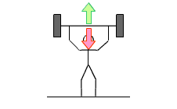
For example, in the force diagram for the weightlifter, the arrows are the same length. As they are the same size and in opposite directions, the resultant force on the bar is zero. Its weight acting downwards is balanced by the upward force provided by the weightlifter. This means that:
- If the bar was already still, it will not start to move
- If the bar was moving, it will continue to move at the same speed and in the same direction
Note that you cannot tell which possibility is correct unless you know if and how the bar was already moving.

Non-zero resultant force
When all the forces are not balanced, the resultant force is not zero. In this case, an object accelerates in the direction of the resultant force. This means that:
- A stationary object begins to move in the direction of the resultant force
- A moving object speeds up, slows down or changes direction depending on the direction of the resultant force
In this diagram of the weightlifter, the resultant force on the bar is not zero. The upwards force is bigger than the downwards force. The resultant force acts in the upwards direction.
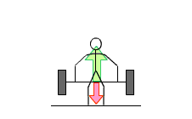
There are three possibilities:
- The bar was still but begins to move upwards
- The bar was already moving upwards and so moves upwards faster than before
- The bar was already moving downwards and so moves downwards more slowly than before
Note that you cannot tell which possibility is correct unless you know if and how the bar was already moving.
In the next diagram of the weightlifter, the resultant force on the bar is again not zero. The upwards force is smaller than the downwards force. The resultant force acts in the downwards direction.
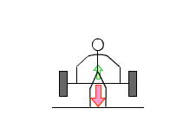
Again there are three possibilities:
- The bar was still but begins to move downwards
- The bar was already moving downwards and so moves downwards faster than before
- The bar was already moving upwards and so moves upwards more slowly than before
As before, you cannot tell which possibility is correct unless you know if and how the bar was already moving.

Force, mass and acceleration
You should know that objects accelerate when the resultant force is not zero, and understand the factors that affect the size of the acceleration.

Size of the force
An object will accelerate in the direction of the resultant force. The bigger the force, the greater the acceleration. Doubling the size of the (resultant) force doubles the acceleration.

The mass
An object will accelerate in the direction of the resultant force. A force on a large mass will accelerate it less than the same force on a smaller mass. Doubling the mass halves the acceleration.

Calculating acceleration
Here is an equation relating acceleration to force and mass:
a = F ÷ m
(It is more often shown as: F = m × a)
- F is the resultant force in Newtons, N
- m is the mass of the object in kilograms, kg
- a is the acceleration of the object in metres per second squared, m/s²
For example, the acceleration of a 10 kg mass with a 50 N resultant force acting on it is:
50 ÷ 10 = 5 m/s²
The same force could accelerate a 1 kg mass by 50 m/s² or a 100 kg mass by 0.5 m/s². You should see that it takes more force to accelerate a larger mass.

The gradient of a distance-time graph represents the speed of an object.
The velocity of an object is its speed in a particular direction. The slope on a velocity-time graph represents the acceleration of an object. The distance travelled is equal to the area under a velocity-time graph.

Distance-time graphs
You should be able to draw and explain distance-time graphs for a stationary object or an object moving at a steady speed in a straight line.

Background information
The vertical axis of a distance-time graph is the distance travelled from the start. The horizontal axis is the time from the start.

Features of the graphs
When an object is stationary, the line on the graph is horizontal. When an object is moving at a steady speed in a straight line, the line on the graph is straight but sloped.
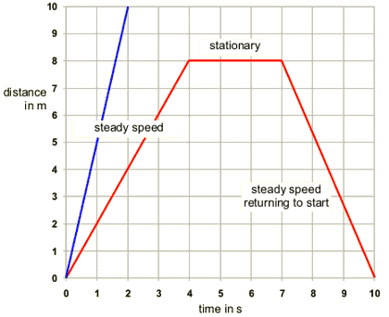
Distance - time graph
Note that the steeper the line, the greater the speed of the object. The blue line is steeper than the red line because the blue line represents an object which is moving more quickly.

Calculating speed - Higher tier
When an object moves in a straight line at a steady speed, you can calculate its speed if you know how far it travels and how long it takes. This equation shows the relationship between speed, distance travelled and time taken:
Speed = distance travelled ÷ time taken
- Speed is measured in metres per second, m/s
- Distance is measured in metres, m
- Time taken is measured in seconds, s
- For example, a car travels 300 m in 20 s. Its average speed is:
- 300 ÷ 20 = 15 m/s

Velocity-time graphs
You should be able to explain velocity-time graphs for objects moving with a constant velocity or constant acceleration.

Background information
The velocity of an object is its speed in a particular direction. This means that two cars will have different velocities if they are travelling at:
- The same speed but in different directions
- The different speeds in the same direction
- The different speeds in different directions
The vertical axis of a velocity-time graph is the velocity of the object. The horizontal axis is the time from the start.

Features of the graphs
When an object is moving with a constant velocity, the line on the graph is horizontal. When an object is moving with a constant acceleration, the line on the graph is straight but sloped.
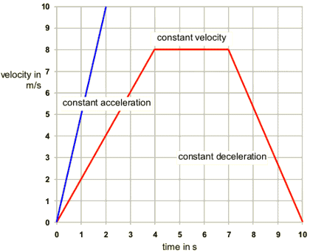
Speed - time graph
The steeper the line, the greater the acceleration of the object. The blue line is steeper than the red line because the blue line represents an object with a greater acceleration.
Notice that a line sloping downwards - with a negative gradient - represents an object with a constant deceleration (slowing down).
Take care not to confuse distance-time graphs with velocity-time graphs.

Acceleration
You should be able to calculate the acceleration of an object from its change in velocity and the time taken.

The equation
When an object moves in a straight line with a constant acceleration, you can calculate its acceleration if you know how much its velocity changes and how long this takes. This equation shows the relationship between acceleration, change in velocity and time taken:
a = (v – u) ÷ t
- a is the acceleration of the object in metres per second squared, m/s²
- v is the final velocity in metres per second, m/s
- u is the initial (starting) velocity in metres per second, m/s
- t is the time taken in seconds, s
The easiest way to do these calculations is to work out the difference between the final velocity and the initial velocity, then divide by the time taken.
- For example, a car accelerates from 25 m/s to 35 m/s in 5 s
- Its velocity changes by 10 m/s (35 – 25)
- So its acceleration is 10 ÷ 5 = 2 m/s²

Distance-time graphs - Higher tier
You should be able to calculate gradients on distance-time graphs.

Background
The gradient of a line on a distance-time graph represents the speed of the object

Distance-time graphs
To calculate the gradient of the line on a graph, divide the change in the vertical axis by the change in the horizontal axis.

Velocity-time graphs - Higher tier
You should be able to calculate gradients of velocity-time graphs and the areas under the graphs.

The gradient
The gradient of a line on a velocity-time graph represents the acceleration of the object. Study this velocity-time graph.
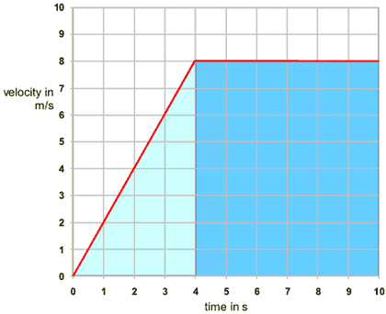
Velocity - time graph

The area
The area under the line in a velocity-time graph represents the distance travelled. To find the distance travelled in the graph above, we need to find the area of the light-blue triangle and the dark-blue rectangle.
- Area of light-blue triangle
  - The width of the triangle is 4 seconds and the height is 8 metres per second. To find the area, you use the equation:
  - area of triangle = ¹⁄₂ × base × height
  - So the area of the light-blue triangle is ¹⁄₂ × 8 × 4 = 16 m.
- Area of dark-blue rectangle
  - The width of the rectangle is 6 seconds and the height is 8 metres per second. So the area is 8 × 6 = 48 m.
- Area under the whole graph
  - The area of the light-blue triangle plus the area of the dark-blue rectangle is:
  - 16 + 48 = 64 m
  - This is the total area under the distance-time graph. This area represents the distance covered.

Summary
- The gradient of a velocity-time graph represents the acceleration
- The area under a velocity-time graph represents the distance covered

The stopping distance of a car depends on two factors - thinking distance and braking distance. Under normal driving conditions, the thinking and braking distance depend on the speed of the car.

Forces on a vehicle
When a vehicle travels at a steady speed the driving force from the engine is balanced by air resistance and other resistive forces. The resultant force is zero.
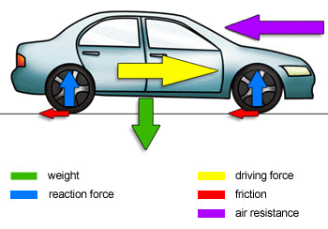
Various forces act on a car in motion.
This diagram shows the forces acting on a car moving at a steady speed:
- Gravity pulls down on the car
- The reaction force from the road pushes up on the wheels
- The driving force from the engine pushes the car along
- There is friction between the road and the tyres
- Air resistance acts on the front of the car

Resultant force
The resultant force is the sum of all the different forces acting on the car.
You have to take account of the directions – the reaction forces on the wheels (blue arrows) add up to the same as the weight (green arrow), so these are balanced.
The driving force from the engine (yellow arrow) is in the opposite direction to the resistive forces of friction (red arrows) and air resistance (purple arrow), so these forces are balanced.
Most of the resistive forces are caused by air resistance.

Speeding up and slowing down
When a vehicle travels at a steady speed the driving force from the engine is balanced by air resistance and other resistive forces. The resultant force is zero – it will not speed up or slow down unless the resultant force is not zero.
This diagram shows the forces acting on a car that is speeding up (accelerating):
- Gravity and the reaction force from the road are balanced – they are equal and opposite
- The driving force from the engine is greater than the resistive forces (friction between the road and the tyres, and air resistance acting on the body of the car)
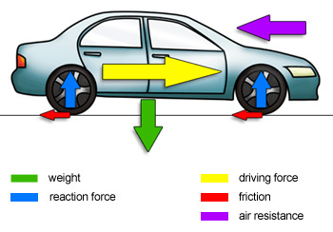
For a vehicle to slow down, one or both of the following have to happen:
- The driving force from the engine must be reduced
- The resistive forces must be increased
In practice, a driver moves their foot from the accelerator pedal to the brake pedal. This reduces the driving force from the engine and increases the resistive force. The braking force is an extra resistive force, which acts when the brakes are used.

Stopping distances
To be a safe driver you need to understand the factors that affect a car's stopping distance:
Stopping distance = thinking distance + braking distance

Thinking distance
It takes time for a driver to react to a situation and start to apply the brakes. The car carries on moving during this reaction time. The thinking distance is the distance travelled in this reaction time. The thinking distance increases if the reaction time increases. This can happen if the driver is:
- Tired
- Distracted
- Under the influence of alcohol or other drugs
The thinking distance also increases as the car's speed increases (as the car will travel further during the reaction time).

Braking distance
The braking distance is the distance taken to stop once the brakes are applied. The braking distance increases if:
- The car's brakes or tyres are in poor condition
- The road and weather conditions are poor (icy or wet roads, for example)
The braking distance also increases as the car’s speed increases.
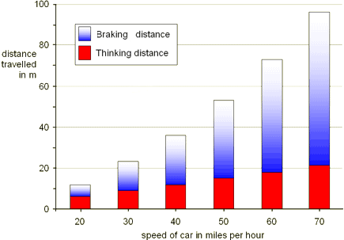
Stopping distances
When the brakes are applied, work is done by the friction force between the brakes and the wheels. This:
- Reduces the kinetic energy of the vehicle (because its speed decreases)
- Increases the temperature of the brakes

Objects falling through a fluid eventually reach terminal velocity, when the resultant force acting on them is zero and they are moving at a steady speed. Weight is a force exerted on an object because of a gravitational force.

Falling objects
You should be able to describe the forces affecting a falling object at different stages of its fall. Usually, you need to think about two forces:
- The weight of the object. This is a force acting downwards, caused by the object’s mass the Earth's gravitational field
- Air resistance. This is a frictional force acting in the opposite direction to the movement of the object.

Three stages of falling
When an object is dropped, we can identify three stages before it hits the ground:
- At the start, the object accelerates downwards because of its weight. There is no air resistance. There is a resultant force acting downwards.
- As it gains speed, the object's weight stays the same, but the air resistance on it increases. There is a resultant force acting downwards.
- Eventually, the object's weight is balanced by the air resistance. There is no resultant force and the object reaches a steady speed, called the terminal velocity.

Terminal velocity
What happens if you drop a feather and a coin together? The feather and the coin have roughly the same surface area, so when they begin to fall they have about the same air resistance.
As the feather falls, its air resistance increases until it soon balances the weight of the feather. The feather now falls at its terminal velocity. But the coin is much heavier, so it has to travel quite fast before air resistance is large enough to balance its weight. In fact, it probably hits the ground before it reaches its terminal velocity.

On the Moon
An astronaut on the Moon carried out a famous experiment. He dropped a hammer and a feather at the same time and found that they landed together. The Moon's gravity is too weak for it to hold onto an atmosphere, so there is no air resistance. When the hammer and feather were dropped, they fell together with the same acceleration.

Velocity-time graphs for falling objects
The graph is a velocity-time graph for an object falling through a fluid (e.g. air, water, oil).
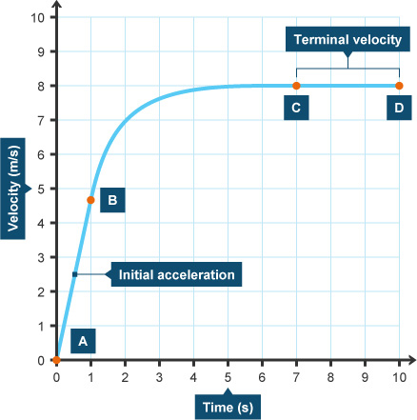

Between A and B
The object accelerates at first because of the force of gravity. Its speed increases. The resultant force acts downwards because frictional force acting against it is less than the weight of the object.

Between B and C
The object is still accelerating but its acceleration decreases as time goes by. Its speed still increases but by a smaller amount as time goes by. The resultant force still acts downwards but is decreasing. This is because frictional force acting against it is increasing as the speed increases, but is still less than the weight of the object.

Between C and D
The object is not accelerating any more. It has reached its terminal velocity and is falling at a steady speed. The resultant force is zero because the frictional force acting against it is now the same as the weight of the object.
Take care: the object does not stop falling once its resultant force is zero (unless it has hit the ground!).

Weight and mass
Weight is not the same as mass. Mass is a measure of how much stuff is in an object. Weight is a force acting on that stuff.
Weight is the result of gravity. The Earth's gravity attracts objects towards the centre of the Earth and you feel forces like this as weight.
Here is the equation that links weight, mass and gravitational field strength:
W = m × g
- W is the weight in newtons, N
- m is the mass in kilograms, kg
- g is the gravitational field strength in newtons per kilogram, N/kg.
You would weigh less on the Moon because the gravitational field strength of the Moon is one-sixth of that of the Earth. But note that your mass would stay the same. For example, what is the weight of an 80 kg person on Earth and on the Moon?
On Earth, g = 10 N/kg, so W = 80 × 10 = 800 N.
On the Moon, g = 1.6 N/kg, so W = 80 × 1.6 = 128 N.
Forces may change the shape of an object. An elastic object such as a spring stores elastic potential energy when stretched or squashed. The extension of an elastic object is directly proportional to the force applied.

Elastic potential energy
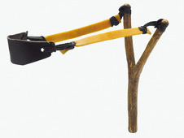
A force acting on an object may cause the shape of an object to change. Elastic objects can store elastic potential energy if they are stretched. For example, this happens when a catapult is used.

Changing shape
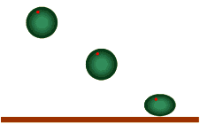
Elastic objects can also store elastic potential energy when they are squashed. For example, this happens when a squash ball is dropped onto a hard surface.
Work is done on an elastic object when its shape changes and it stores elastic potential energy. It is possible to calculate the amount of energy stored when stretching or squashing an elastic material, but you do not need to be able to do this for your examination.

Hooke's Law
When an elastic object - such as a spring - is stretched, the increased length is called its extension. The extension of an elastic object is directly proportional to the force applied to it:
F = k × e
- F is the force in newtons, N
- k is the 'spring constant' in newtons per metre, N/m
- e is the extension in metres, m
This equation works as long as the elastic limit (the limit of proportionality) is not exceeded. If a spring is stretched too much, for example, it will not return to its original length when the load is removed.

The spring constant
The spring constant k is different for different objects and materials. It is found by carrying out an experiment. For example, the unloaded length of a spring is measured. Different numbers of slotted masses are added to the spring and its new length measured each time. The extension is the new length minus the unloaded length.
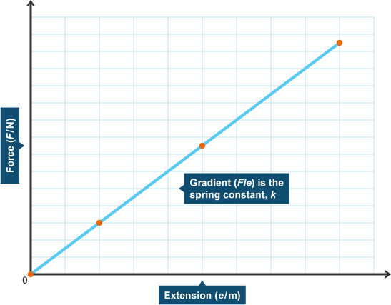
Graph showing Hooke's Law. Extension is plotted against force.
Assuming the limit of proportionality (elastic limit) is not exceeded, a graph of force against extension produces a straight line that passes through the origin. The gradient of the line is the spring constant, k. The greater the value of k, the stiffer the spring.

Forces and energy
Work done and energy transferred are measured in joules, J. The work done on an object can be calculated if the force and distance moved are known. Power is a measure of how quickly work is being done. Objects gain gravitational energy when they are raised. Moving objects have kinetic energy.

Work, force and distance
Work is done whenever a force moves something.
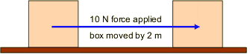
Everyday examples of work include walking up stairs, or lifting heavy objects. Whenever work is done, energy is transferred from one place to another. Both energy and work are measured in joules, J.

Calculating work done
Here is the equation which relates work done to force and distance:
W = F × d
- W is the work done in joules, J
- F is the force applied in newtons, N
- d is the distance moved in the direction of the force in metres, m
- In the diagram above, 10 N is applied to move the box 2 m.
- Work done = 10 × 2 = 20 J

Power
Power is a measure of how quickly work is being done and so how quickly energy is being transferred.

Calculating power
Here is the equation which relates power to work done (or energy transferred) and time:
P = E ÷ t
- P is the power in watts, W
- E is the work done (or energy transferred) in joules, J
- t is the time taken in seconds, s.
- For example, an electric drill transfers 3000 J in 15 s. What is its power?
- Power = 3000 ÷ 15 = 200 W

Gravitational potential energy
On Earth we always have the force of gravity acting on us. When we are above the Earth’s surface we have potential (stored) energy. This is called gravitational potential energy. The amount of gravitational potential energy an object on Earth has depends on its:
- Mass
- Height above the ground
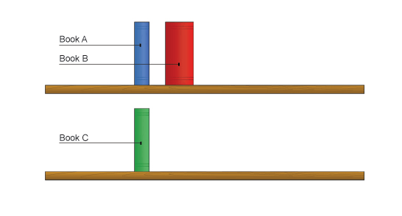
In the diagram above:
- All the books on a shelf have gravitational potential energy
- Book A has more than book C because it is higher
- Book B has more than book A because it has a greater mass

Calculating change in gravitational potential energy
If an object is lifted, work is done against gravitational force. The object gains energy. For example, Book C would gain gravitational potential energy if it were lifted onto the higher book shelf alongside Books A and B.
Here is the equation for calculating change in gravitational potential energy:
E_{p} = m × g × h
- E_{p} is the change in gravitational potential energy in joules, J
- m is the mass in kilograms, kg
- g is the gravitational field strength in newtons per kilogram, N/kg
- h is the change in height in metres, m
- For example, a book with a mass of 0.25 kg is lifted 2 m onto a bookshelf. If g is 10 N/kg, what is the change in gravitational potential energy?
- E_{p} = 0.25 × 10 × 2 = 5 J

Kinetic energy
All moving objects have kinetic energy. The kinetic energy an object has depends on its:
- Mass
- Speed

Calculating kinetic energy
Here is the equation for calculating kinetic energy:
E_{k} = ½ × m × v²
- E_{k} is the kinetic energy in joules, J
- m is the mass in kilograms, kg
- v is the speed in metres per second, m/s.
- For example, what is the kinetic energy of a 1000 kg car travelling at 5 m/s?
- E_{k} = ½ × 1000 × 5² = 500 × 25 = 12500 J

The pendulum
The pendulum is a simple machine for transferring gravitational potential energy to kinetic energy, and back again.
When the bob is at the highest point of its swing, it has no kinetic energy, but its gravitational potential energy is at a maximum. As the bob swings downwards, gravitational potential energy is transferred to kinetic energy, and the bob accelerates.
At the bottom of its swing, the bob’s kinetic energy is at a maximum and its gravitational potential energy is at a minimum.
As the bob swings upwards, its kinetic energy is transferred to gravitational potential energy again. At the top of its swing, it once again has no kinetic energy, but its gravitational potential energy is at a maximum.
Note that the bob’s swing will become lower with each swing, because some energy is also transferred as heat to the surroundings.
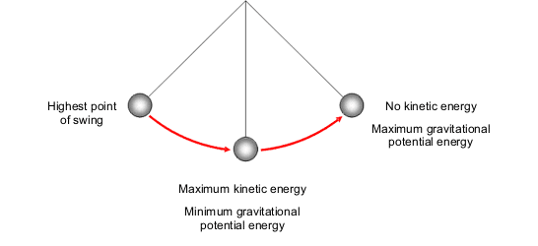

Momentum
A change in momentum happens when a force is applied to an object that is moving or is able to move. The total momentum in an explosion or collision stays the same.

What is momentum?
A moving object has momentum. This is the tendency of the object to keep moving in the same direction. It is difficult to change the direction of movement of an object with a lot of momentum.

Calculating momentum
You can calculate momentum using this equation:
p = m × v
- p is the momentum in kilograms metres per second, kg m/s
- m is the mass in kilograms, kg
- v is the velocity in m/s
- For example, what is the momentum of a 5 kg object moving with a velocity of 2 m/s?
- Momentum = 5 × 2 = 10 kg m/s

Direction
Notice that momentum does not just depend on the object’s mass and speed. Velocity is speed in a particular direction, so the momentum of an object also depends on the direction of travel. This means that the momentum of an object can change if:
- The object speeds up or slows down
- The object changes direction

Conservation of momentum
As long as no external forces are acting on the objects involved, the total momentum stays the same in explosions and collisions. We say that momentum is conserved. You can use this idea to work out the mass, velocity or momentum of an object in an explosion or collision.

Momentum calculations
Here is a typical conservation of momentum question:
Two railway carriages collide and move off together. Carriage A has a mass of 12,000 kg and moves at 5 m/s before the collision. Carriage B has a mass of 8,000 kg and is stationary before the collision. What is the velocity of the two carriages after the collision?
Step 1 – work out the total momentum before the event (before the collision):
p = m × v
- Momentum of carriage A before = 12,000 × 5 = 60,000 kg m/s
- Momentum of carriage B before = 8,000 × 0 = 0 kg m/s
- Total momentum before = 60,000 + 0 = 60,000 kg m/s.
Step 2 – work out the total momentum after the event (after the collision):
- Because momentum is conserved, total momentum afterwards = 60,000 kg m/s
Step 3 – work out the total mass after the event (after the collision):
- Total mass = mass of carriage A + mass of carriage B = 12,000 + 8,000 =20,000 kg
Step 4 – work out new velocity:
p = m × v ... so ... v = p ÷ m
- Velocity (after the collision) = 60,000 ÷ 20,000 = 3 m/s

Static electricity

Some insulating materials become electrically charged when they are rubbed together. Charges that are the same repel, while unlike charges attract.

Attraction and repulsion
You should know how and why insulators can be electrically charged.

Moving charges
When you rub two different insulating materials against each other they become electrically charged. This only works for insulated objects. Electrical charges move easily to earth through conductors such as metals.
When the materials are rubbed against each other:
- Negatively charged particles called electrons move from one material to the other
- The material that loses electrons becomes positively charged
- The material that gains electrons becomes negatively charged
- Both materials gain an equal amount of charge, but the charges are opposite

Detecting charge
Two charged objects will repel each other if they have the same type of charge (they are both positive or both negative). Two charged objects will attract each other if they have opposite charges.

Current and voltage in electrical circuits
Electrical circuits can be represented by circuit diagrams. The various electrical components are shown by using standard symbols in circuit diagrams. Components can be connected in series, or in parallel. The characteristics of the current and potential difference (voltage) are different in series and parallel circuits.

Circuit symbols
You need to be able to draw and interpret circuit diagrams.

Standard symbols
The diagram below shows the standard circuit symbols you need to know.

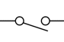  Open Switch | 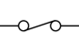  Closed Switch | 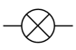  Lamp | 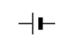  Cell
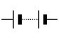  Battery | 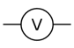  Voltmeter | 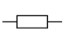  Resistor | 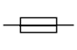  Fuse
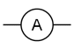  Ammeter | 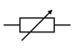  Variable resistor | 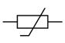  Thermistor | 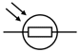  Light dependent resistor (LDR)
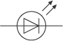  Light emitting diode (LED) | 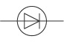  Diode

Circuit diagrams
Two things are important for a circuit to work:
- There must be a complete circuit
- There must be no short circuits
To check for a complete circuit, follow a wire coming out of the battery with your finger. You should be able to go out of the battery, through the lamp, and back to the battery.
To check for a short circuit, see if you can find a way past the lamp without going through any other component. If you can, there is a short circuit and the lamp will not light.

Series and parallel connections
You should know the difference between series and parallel connections in circuits.

Series connections
Components that are connected one after another on the same loop of the circuit are connected in series. The current that flows across each component connected in series is the same.

Two lamps connected in series
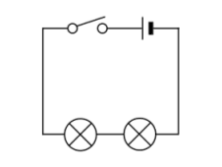
The circuit diagram shows a circuit with two lamps connected in series. If one lamp breaks, the other lamp will not light.

Parallel connections
Components that are connected on separate loops are connected in parallel. The current is shared between each component connected in parallel.

Two lamps connected in parallel
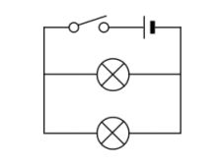
The circuit diagram shows a circuit with two lamps connected in parallel. If one lamp breaks, the other lamp will still light.

Electric current
Electric current is a flow of electric charge. No current can flow if the circuit is broken - for example, when a switch is open. Click on the animation to see what happens to the charges when the switch is opened or closed:

Measuring current
Current is measured in amperes (which is often abbreviated to amps or A). The current flowing through a component in a circuit is measured using an ammeter. This must be connected in series with the component.
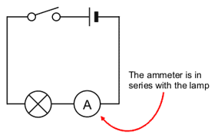

Calculating current
The size of an electric current is the rate of flow of electric charge. You can calculate the size of a current using this equation:
I = Q ÷ t
- I is the current in amperes (amps), A
- Q is the charge in coulombs, C
- t is the time in seconds, s
- For example, what is the current if 20 C of charge passes in 5 s?
- Current = 20 ÷ 5 = 4 A

Potential difference (voltage)
A potential difference, also called voltage, across an electrical component is needed to make a current flow through it. Cells or batteries often provide the potential difference needed.

Measuring potential difference
Potential difference is measured in volts, V. The potential difference across a component in a circuit is measured using a voltmeter. This must be connected in parallel with the component.
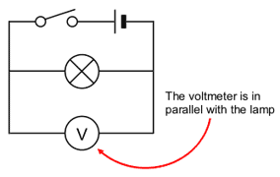

Calculating potential difference
The potential difference between two points in an electric circuit is the work done when a coulomb of charge passes between the points. You can calculate the size of a potential difference using this equation:
V = W ÷ Q
- V is the potential difference in volts, V
- W is the work done (energy transferred) in joules, J
- Q is the charge in coulombs, C
- For example, what is the potential difference if 48 J of energy is transferred when 4 C of charge passes?
- Potential difference = 48 ÷ 4 = 12 V

Cells and circuits
You should know what happens to the potential difference and current when the number of cells in a circuit is changed.

Potential difference
A typical cell produces a potential difference of 1.5 V. When two or more cells are connected in series in a circuit, the total potential difference is the sum of their potential differences. For example, if two 1.5 V cells are connected in series in the same direction, the total potential difference is 3.0 V. If two 1.5V cells are connected in series, but in opposite directions, the total potential difference is 0V, so no current will flow.

Current
When more cells are connected in series in a circuit, they produce a bigger potential difference across its components. More current flows through the components as a result.

Series circuits
You should know the characteristics of the current and potential difference in series circuits.

Current
When two or more components are connected in series, the same current flows through each component.

Potential difference
When two or more components are connected in series, the total potential difference of the supply is shared between them. This means that if you add together the voltages across each component connected in series, the total equals the voltage of the power supply.

Resistance is measured in ohms. It can be calculated from the potential difference across a component and the current flowing through it. The total resistance of a series circuit is the sum of the resistances of the components in the circuit.
Resistors, filament lamps and diodes produce different current-potential difference graphs. The resistance of thermistors depends on the temperature, while the resistance of light-dependent resistors (LDRs) depends on the light intensity.

Resistance
There is a resistance to the flow of an electric current through most conductors.
The resistance in a wire increases as:
- The length of the wire increases
- The thickness of the wire decreases

Resistance - Higher tier
An electric current flows when electrons move through a conductor, such as a metal wire. The moving electrons can collide with the ions in the metal. This makes it more difficult for the current to flow, and causes resistance.
The resistance of a long wire is greater than the resistance of a short wire because electrons collide with ions more often.
The resistance of a thin wire is greater than the resistance of a thick wire because a thin wire has fewer electrons to carry the current.

Measuring resistance
The resistance of a component can be found by measuring the current flowing through it, and the potential difference across it.
This equations shows the relationship between potential difference, current and resistance:
V = I × R
- V is the potential difference in volts, V
- I is the current in amperes (amps), A
- R is the resistance in ohms, Ω
The equation can be rearranged to find the resistance:
R = V ÷ I
- For example, 3 A flows through a 240 V lamp. What is the resistance of the lamp?
- Resistance = 240 ÷ 3 = 80 Ω

A graph of current against potential difference shows you how the current flowing through a component varies with the potential difference across it.
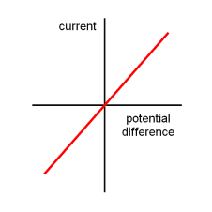
A graph with current on the y axis and voltage on the x axis. A diagonal line goes through the graph at 45 degrees
The current flowing through a resistor at a constant temperature is directly proportional to the potential difference across it. This is the graph of current against potential difference for a resistor at constant temperature.

The filament lamp
Lamp
The filament lamp is a common type of light bulb. It contains a thin coil of wire called the filament. This heats up when an electric current passes through it, and produces light as a result.
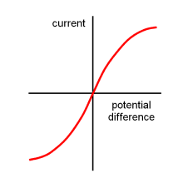
The resistance of a lamp increases as the temperature of its filament increases. The current flowing through a filament lamp is not directly proportional to the voltage across it. This is the graph of current against potential difference for a filament lamp.

Higher tier only
An electric current flows when electrons move through a conductor, such as a metal wire. The moving electrons can collide with the ions in the metal. This makes it more difficult for the current to flow, and causes resistance. As the temperature increases, the metal ions vibrate more. There are more collisions with the electrons and so the resistance increases.

The diode
Diodes are electronic components which can be used to regulate the potential difference in circuits and to make logic gates.
Diode
The diode has a very high resistance in one direction. This means that current can only flow in the other direction. This is the graph of current against potential difference for a diode:
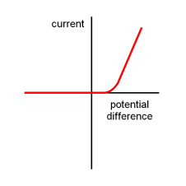

LEDs
Light emitting diode (LED)
A light-emitting diode, LED, produces light when a current flows through it in the forward direction. LEDs are often used for indicator lights in electrical equipment such as computers and television sets. As LEDs use a much smaller current than other types of lighting, their use is increasing.

Thermistors and LDRs
You should be able to recognise the circuit symbols for the thermistor and the LDR (light-dependent resistor), and know how the resistance of these components can be changed.

The thermistor
Thermistor
Thermistors are used as temperature sensors - for example, in fire alarms. Their resistance decreases as the temperature increases:
- At low temperatures, the resistance of a thermistor is high and little current can flow through them
- At high temperatures, the resistance of a thermistor is low and more current can flow through them

The LDR
Light dependent resistor (LDR)
LDRs (light-dependent resistors) are used to detect light levels, for example, in automatic security lights. Their resistance decreases as the light intensity increases:
- In the dark and at low light levels, the resistance of an LDR is high and little current can flow through it
- In bright light, the resistance of an LDR is low and more current can flow through it

Household electricity

Electrical supplies can be direct current (DC) or alternating current (AC).The UK mains electricity supply is about 230V at 50 Hz. It can kill if not used safely. Electrical circuits, cables, plugs and appliances are designed to reduce the chances of receiving an electric shock.

Direct current and alternating current
You should know the differences between direct current (DC) and alternating current (AC) electrical supplies.

Direct current
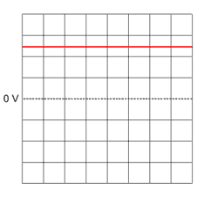
Direct current
If the current flows in only one direction it is called direct current (DC). Batteries and cells supply DC electricity, with a typical battery supplying around 1.5 V. The diagram shows an oscilloscope screen displaying the signal from a DC supply.

Alternating current
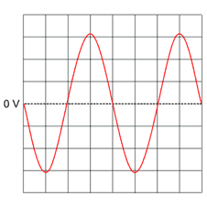
Alternating current
If the current constantly changes direction, it is called alternating current (AC). Mains electricity is an AC supply, with the UK mains supply being about 230 V. It has a frequency of 50 Hz (50 hertz), which means it changes direction, and back again, 50 times a second. The diagram shows an oscilloscope screen displaying the signal from an AC supply.

Cables and plugs
You should know the features of a correctly wired three-pin mains electricity plug and be able to recognise errors in the wiring of a plug.

The cable
A mains electricity cable contains two or three inner wires. Each has a core of copper, because copper is a good conductor of electricity. The outer layers are flexible plastic, because plastic is a good electrical insulator. The inner wires are colour coded:

Colours of inner wires within a cable
Colour | Wire
blue | neutral
brown | live
green and yellow stripes | earth

The plug
The features of a plug are:
- The case is made from tough plastic or rubber, because these materials are good electrical insulators.
- The three pins are made from brass, which is a good conductor of electricity.
- There is a fuse between the live terminal and the live pin.
- The fuse breaks the circuit if too much current flows.
- The cable is secured in the plug by a cable grip. This should grip the cable itself, and not the individual wires inside it.
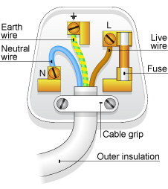
The inside of a plug
The blue neutral wire goes to the left, the brown live wire to the right and the green and yellow striped earth wire is on top. The fuse fits next to the live wire.
The diagram shows the key features of a three-pin mains plug.

Where does each wire go?
There is an easy way to remember where to connect each wire. Take the second letters of the words 'blue', 'brown' and 'striped'. This reminds you that when you look into a plug from above:
- Blue goes left
- Brown goes right
- Striped goes to the top

Fuses
Fuses protect electrical circuits and appliances.
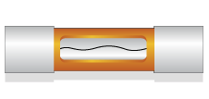
A 13A fuse with a low melting point wire
The fuse breaks the circuit if a fault in an appliance causes too much current flow. This protects the wiring and the appliance if something goes wrong. The fuse contains a piece of wire which melts easily. If the current going through the fuse is too great, the wire heats up until it melts and breaks the circuit.
Fuses in plugs are made in standard ratings. The most common are 3 A, 5 A and 13 A. The fuse should be rated at a slightly higher current than the device needs:
- If the device works at 3 A, use a 5 A fuse
- If the device works at 10 A, use a 13 A fuse

Circuit breakers
Residual current circuit breakers, RCCBs, protect some circuits. They detect a difference in the current between the live and neutral wires. RCCBs work much faster than fuses do. For the examination, you do not need to know how they work.

Earthing
Many electrical appliances - including cookers, washing machines and refrigerators - have metal cases. The earth wire creates a safe route for the current to flow through if the live wire touches the casing.
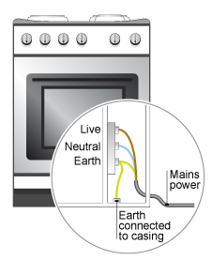
Earthing of an electric cooker
You would get an electric shock if the live wire inside an appliance, such as a cooker, came loose and touched the metal casing.
However, the earth terminal is connected to the metal casing so that the current goes through the earth wire instead of causing an electric shock. A strong current surges through the earth wire because it has a very low resistance. This breaks the fuse and disconnects the appliance.

Double insulation

Symbol for double insulation
Some appliances - such as vacuum cleaners and electric drills - do not have an earth wire. This is because they have plastic casings, or they have been designed so that the live wire cannot touch the casing. As a result, the casing cannot give an electric shock, even if the wires inside become loose. These appliances have double insulation and carry a symbol.

Oscilloscope traces - Higher tier
Alternating current
You should be able to calculate the period and frequency of an AC (alternating current) supply from an oscilloscope trace, such as the one here.

Period
The period of an AC supply is the time taken for one complete oscillation. You can find this by looking at the time between one peak and the next, between one trough and the next, or between any two identical places on adjacent oscillations.
In the oscilloscope trace on this page, one horizontal division represents 5 ms (five milliseconds).
There are four divisions between two adjacent peaks, so the period is:
4 × 5 = 20 ms

Frequency
The frequency of an AC supply is the number of oscillations per second. You can find it from the period:
Frequency = 1 ÷ period
Remember to convert to seconds if needed. In this example, 20 ms = 20 ÷ 1000 =0.020 s.
Frequency = 1 ÷ 0.020 = 50 Hz
UK mains frequency is 50 Hz but you may get other frequencies (and periods) to calculate in the examination.

Charge, current and power
Some electrical appliances transfer energy more efficiently than others. The power of an appliance can be calculated. The current flowing through an appliance can be calculated, allowing the most appropriate fuse to be chosen.

Choosing appliances
People have a choice when deciding which new appliance to buy. Some are more efficient at transferring energy than others. For example, less energy is 'wasted' as heat energy from energy-saving lamps (such as LEDs) and compact fluorescent lamps (CFLs) than from filament lamps.

Filament lamps
Filament lamps contain a thin metal filament that glows when electricity passes through it. However, most of the electrical energy is transferred as heat energy instead of light energy. This is a Sankey diagram for a typical filament lamp.
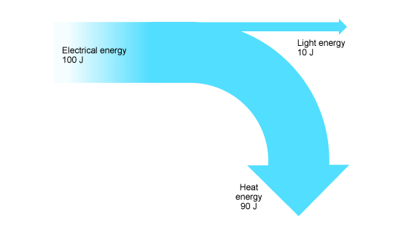
Sankey diagram for a filament lamp

Energy-saving lamps
Modern energy-saving lamps work in a different way. They transfer a greater proportion of electrical energy as light energy. This is a Sankey diagram for a typical energy-saving lamp.
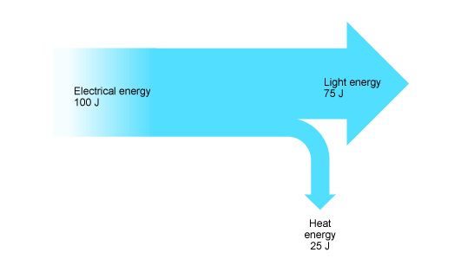
Sankey diagram for a typical energy-saving lamp
You can see that with the energy-saving lamp, much less electrical energy is transferred - or 'wasted' - as heat energy.

Power
Power is a measure of how quickly energy is transferred. The unit of power is the watt, W.
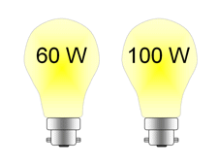
The more energy that is transferred in a certain time, the greater the power. A 100 W light bulb transfers more electrical energy each second than a 60 W light bulb.

Calculating power
You can work out power using this equation:
P = E ÷ t
- P is the power in watts, W
- E is the energy transferred (or work done) in joules, J
- T is the time in seconds, s
- For example, an electric lamp transfers 500 J in 5 s. What is its power?
- Power = 500 ÷ 5 = 100 W

P = IV and fuses
The power of an electrical appliance can be calculated from the current that flows through it and the potential difference across it.

Calculating power (again)
You can work out power using this equation:
P = I × V
- P is the power in watts, W
- I is the current in amperes (amps), A
- V is the potential differences in volts, V
- For example, what is the power of a 5 A 1.5 V lamp?
- Power = 5 × 1.5 = 7.5 W

Working out the best fuse to use
The equation P = I × V can be rearranged to find the current if the power and potential difference are known:
I = P ÷ V
For example, what current flows through a 1.15 kW electric fire at a potential difference of 230 V? Remember that 1.15 kW is 1,150 W.
Current = 1150 ÷ 230 = 5A
Fuses come in standard ratings of 3 A, 5 A or 13 A.
The best fuse to use in this example would be the 13A fuse. The 3A and 5A fuses would blow even when the fire was working normally.

E = VQ - Higher tier
For a given amount of electrical charge that moves, the amount of energy transferred increases as the potential difference (voltage) increases.

Calculating energy transferred
You can work out the energy transferred using this equation:
E = V×Q
- E is the energy transferred in joules, J
- V is the potential differences in volts, V
- Q is the charge in coulombs, C
- For example, much energy is transferred when the potential difference is 120 V and the charge is 2 C?
- Energy transferred = 120 × 2 = 240 J

Atoms and radiation

Atomic structure
An atom is made from a nucleus surrounded by electrons. The nucleus contains protons and neutrons. Isotopes are atoms that have the same number of protons, but different numbers of neutrons.
An early model of the atom was the plum pudding model. It was disproved by Rutherford's scattering experiment and replaced by the nuclear model.

Structure of the atom
You should be able to describe the nuclear model of the atom.

The nuclear model
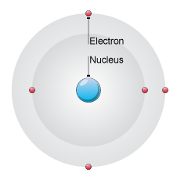
The structure of the atom
Atoms contain three sub-atomic particles called protons, neutrons and electrons. The protons and neutrons are found in the nucleus at the centre of the atom. The nucleus is very much smaller than the atom as a whole. The electrons are arranged in energy levels around the nucleus.
The table shows the properties of these three sub-atomic particles.

Properties of sub-atomic particles
Particle | Relative mass | Relative charge
Proton | 1 | +1
Neutron | 1 | 0
Electron | Almost zero | –1
The number of electrons in an atom is always the same as the number of protons, so atoms are electrically neutral overall. Atoms can lose or gain electrons. When they do, they form charged particles called ions:
- If an atom loses one or more electrons, it becomes a positively charged ion
- If an atom gains one or more electrons, it becomes a negatively charged ion

Evidence for atomic structure
You should be able to interpret information about Rutherford's scattering experiment.

The 'plum pudding' model of the atom

The plum pudding model
An early model (scientific idea) about the structure of the atom was called the plum pudding model. In this model, the atom was imagined to be a sphere of positive charge with negatively charged electrons dotted around inside it - like plums in a pudding.
Scientific models can be tested to see if they are wrong by doing experiments. An experiment carried out in 1905 showed that the plum pudding model could not be correct.

Rutherford's scattering experiment
A scientist called Ernest Rutherford designed an experiment to test the plum pudding model. It was carried out by his assistants Hans Geiger and Ernest Marsden.
A beam of alpha particles was aimed at very thin gold foil and their passage through the foil detected. The scientists expected the alpha particles to pass straight through the foil, but something else also happened.
Some of the alpha particles emerged from the foil at different angles, and some even came straight back. The scientists realised that the positively charged alpha particles were being repelled and deflected by a tiny concentration of positive charge in the atom.
As a result of this experiment, the plum pudding model was replaced by the nuclear model of the atom.

Isotopes

Atomic number and mass number
The number of protons in the nucleus of an atom is called its atomic number:
- The atoms of a particular element all have the same number of protons
- The atoms of different elements have different numbers of protons
The total number of protons and neutrons in an atom is called its mass number.
This is the full chemical symbol for chlorine-35.
The proton number is shown below the chemical symbol, and the mass number is shown above. In the example below, the atomic number is 17 and the mass number is 35. This means that each of these atoms has:
- 17 protons
- 17 electrons
- 35 - 17 = 18 neutrons
Isotopes are the atoms of an element with different numbers of neutrons. They have the same proton number, but different mass numbers.

Three isotopes of hydrogen
isotope | symbol
hydrogen-1  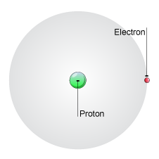  1 proton, 0 neutron, 1 electron | 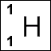
hydrogen-2  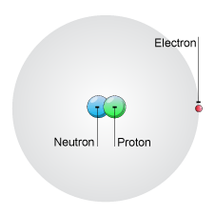  1 proton, 1 neutron, 1 electron | 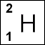
hydrogen-3  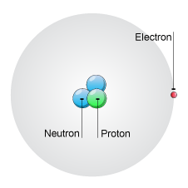  1 proton, 2 neutrons, 1 electron | 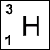

Nuclear radiation
Most background radiation comes from natural sources, while most artificial radiation comes from medical examinations, such as x-ray photographs.
Radiation can damage cells and make them cancerous.
Radiation also has many practical uses. It can be used in medicine to trace where certain chemicals collect in the body, and also in industry, to control measuring equipment.

Background radiation
Background radiation is all around us. Some of it comes from natural sources and some comes from artificial sources.

Natural sources
Natural sources of background radiation include:
- Cosmic rays - radiation that reaches the Earth from space
- Rocks and soil - some rocks are radioactive and give off radioactive radon gas
- Living things - plants absorb radioactive materials from the soil and these pass up the food chain
For most people, natural sources contribute the most to their background radiation dose.
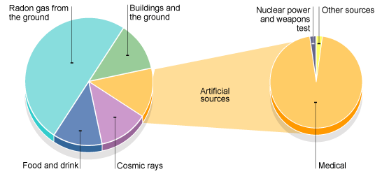
Average contribution of different sources to natural background radiation

Artificial sources
There is little we can do about natural background radiation. After all, we cannot stop eating, drinking or breathing to avoid it!
However, human activity has added to background radiation by creating and using artificial sources of radiation. These include radioactive waste from nuclear power stations, radioactive fallout from nuclear weapons testing and medical x-rays.
Artificial sources account for about 15 per cent of the average background radiation dose. Nearly all artificial background radiation comes from medical procedures such as receiving x-rays for x-ray photographs.

Detecting radiation
Human senses cannot detect radiation, so we need equipment to do this.

Photographic film
Photographic film goes darker when it absorbs radiation, just like it does when it absorbs visible light. The more radiation the film absorbs, the darker it is when it is developed.
People who work with radiation wear film badges, which are checked regularly to monitor the levels of radiation absorbed. The diagram shows a typical radiation badge when it is closed and what the inside looks like when it is opened.
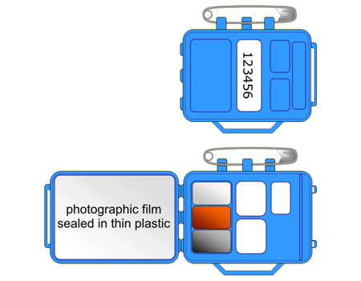
A typical radiation badge
There is a light-proof packet of photographic film inside the badge. The more radiation this absorbs, the darker it becomes when it is developed. To get an accurate measure of the dose received, the badge contains different materials that the radiation must penetrate to reach the film. These may include aluminium, copper, lead-tin alloy and plastic. There is also an open area at the centre of the badge.

Geiger-Muller tube
The Geiger-Muller tube detects radiation. Each time it absorbs radiation, it transmits an electrical pulse to a counting machine. This makes a clicking sound or displays the count rate. The greater the frequency of clicks, or the higher the count rate, the more radiation the Geiger-Muller tube is absorbing.

Types of radiation
There are three main types of radiation emitted from radioactive atoms. These are alpha, beta and gamma radiation.

Alpha radiation
Alpha radiation consists of alpha particles. An alpha particle is identical to the nucleus of a helium atom, which comprises two protons and two neutrons.
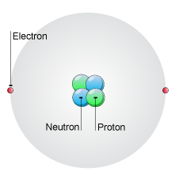
Helium atom
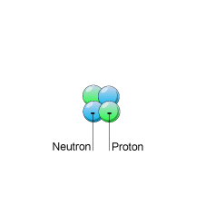
Alpha particle
- 2 protons
- 2 neutrons
- 2 electrons
- 2 protons
- 2 neutrons
- 0 electrons

Beta radiation
Beta radiation consists of high energy electrons emitted from the nucleus. These electrons have not come from the electron shells or energy levels around the nucleus. Instead, they form when a neutron splits into a proton and an electron. The electron then shoots out of the nucleus at high speed.

Gamma radiation
Gamma radiation is very short wavelength - high frequency - electromagnetic radiation. This is similar to other types of electromagnetic radiation such as visible light and x-rays, which can travel long distances.

Penetrating properties of radiation
Radiation can be absorbed by substances in its path. For example, alpha radiation travels only a few centimetres in air, beta radiation travels tens of centimetres in air and gamma radiation travels many metres. All types of radiation become less intense the further the distance from the radioactive material, as the particles or rays become more spread out.
The thicker the substance, the more the radiation is absorbed. The three types of radiation penetrate materials in different ways.

Alpha radiation
Alpha radiation is the least penetrating. It can be stopped - or absorbed - by just a sheet of paper.

Beta radiation
Beta radiation can penetrate air and paper. It can be stopped by a thin sheet of aluminium.

Gamma radiation
Gamma radiation is the most penetrating. Even small levels can penetrate air, paper or thin metal. Higher levels can only be stopped by many centimetres of lead or many metres of concrete.
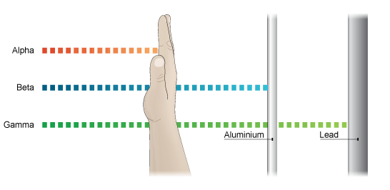
Penetrative properties of different types of radiation

Deflecting radiation

Electric fields
Alpha particles are positively charged, beta particles are negatively charged and gamma radiation is electrically neutral. This means that alpha radiation and beta radiation can be deflected by electric fields, but gamma radiation is not deflected.
Remember that opposite charges attract. Beta particles are negatively charged so they will be attracted towards a positively charged plate. And positive alpha particles will be attracted towards a negatively charged plate.

Magnetic fields
Because they consist of charged particles, alpha radiation and beta radiation can also be deflected by magnetic fields. Just as with electric fields, gamma radiation is not deflected by magnetic fields.

Hazards of radiation

Radiation and living cells
When radiation collides with molecules in living cells it can damage them. If the DNA in the nucleus of a cell is damaged, the cell may become cancerous. The cell then goes out of control, divides rapidly and causes serious health problems.
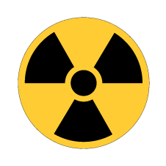
Radiation warning symbol
The greater the dose of radiation a cell gets, the greater the chance that the cell will become cancerous. However, very high doses of radiation can kill the cell completely. We use this property of radiation to kill cancer cells, and also harmful bacteria and other micro-organisms.
The hazard symbol is shown on containers of radioactive substances to warn of the danger.

Alpha, beta and gamma radiation
The degree to which each different type of radiation is most dangerous to the body depends on whether the source is outside or inside the body.
If the radioactive source is inside the body, perhaps after being swallowed or breathed in:
- Alpha radiation is the most dangerous because it is easily absorbed by cells
- Beta and gamma radiation are not as dangerous because they are less likely to be absorbed by a cell and will usually just pass right through it
If the radioactive source is outside the body:
- Alpha radiation is not as dangerous because it is unlikely to reach living cells inside the body
- Beta and gamma radiation are the most dangerous sources because they can penetrate the skin and damage the cells inside
Notice that these effects are opposites and make sure you get them the right way around.

Half-life
The nuclei of radioactive atoms are unstable. They break down and change into a completely different type of atom. This is called radioactive decay. For example, carbon-14 decays to nitrogen-14 when it emits beta radiation.
It is not possible to predict when an individual atom might decay. But it is possible to measure how long it takes for half the nuclei of a piece of radioactive material to decay. This is called the half-life of the radioactive isotope.

Two definitions
There are two definitions of half-life, but they mean essentially the same thing:
- The time it takes for the number of nuclei of the isotope in a sample to halve
- The time it takes for the count rate from a sample containing the isotope to fall to half its starting level
Different radioactive isotopes have different half-lives. For example, the half-life of carbon-14 is 5,715 years, but the half-life of francium-223 is just 20 minutes.

Graphs
It is possible to find out the half-life of a radioactive substance from a graph of the count rate against time. The graph shows the decay curve for a radioactive substance.
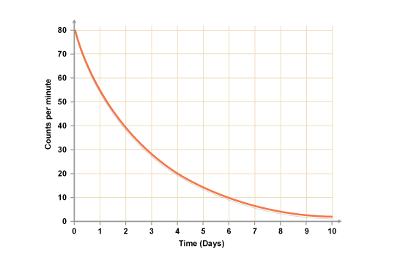
The decay curve for a radioactive substance
The count rate drops from 80 to 40 counts a minute in two days, so the half-life is two days. In the next two days, it drops from 40 to 20 - it halves. In the two days after that, it drops from 20 to 10 - it halves again - and so on.

Using radiation
Here are some examples of how radiation is used:
- In smoke detectors
- For sterilising medical instruments
- For killing cancer cells
- For dating rocks and materials such as archaeological finds
- In chemical tracers to help with medical diagnosis
- For measuring the thickness of materials in, for example, a paper factory

Tracers
Doctors may use radioactive chemicals called tracers for medical imaging. Certain chemicals concentrate in different damaged or diseased parts of the body, and the radiation concentrates with it. Radiation detectors placed outside the body detect the radiation emitted and, with the aid of computers, build up an image of the inside of the body.
When a radioactive chemical is used in this way it is not normally harmful, because:
- It has a short half-life and so decays before it can do much damage
- It is not poisonous
Emitters of beta radiation or gamma radiation are used because these types of radiation readily pass out of the body, and they are less likely to be absorbed by cells than alpha radiation.

Monitoring the thickness of materials
Radiation is used in industry in detectors that monitor and control the thickness of materials such as paper, plastic and aluminium. The thicker the material, the more radiation is absorbed and the less radiation reaches the detector. It then sends signals to the equipment that adjusts the thickness of the material.

Nuclear equations - Higher tier
You need to be able to write nuclear equations to show single alpha and beta decay.

Symbols
The nucleus of an atom can be represented as:
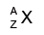
In this symbol:
- A is the atomic mass (number of protons + neutrons)
- Z is the atomic number (number of protons)
- X is chemical symbol (as shown on the Periodic Table)

Alpha decay
Two protons and two neutrons are lost from a nucleus when it emits an alpha particle. This means that:
- The atomic mass number decreases by 4
- The atomic number decreases by 2
A new element is formed that is two places lower in the Periodic Table than the original element.
For example, radon decays into polonium when it emits an alpha particle. Here is the equation for that radioactive decay:
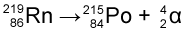

Beta decay
In beta decay, a neutron changes into a proton plus an electron. The proton stays in the nucleus. The electron leaves the atom with high energy as a beta particle.
The nucleus has one more proton and one less neutron when it emits a beta particle. This means that:
- The atomic mass number stays the same
- The atomic number increases by 1
For example, carbon-14 is a radioactive isotope of carbon. Here is the equation for the beta decay of carbon-14 into nitrogen:
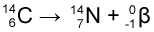

Nuclear fission and fusion
Nuclear reactors use a type of nuclear reaction called nuclear fission. Another type of nuclear reaction - nuclear fusion - happens in the Sun and other stars.

Nuclear fission
Nuclear power reactors use a reaction called nuclear fission. Two isotopes in common use as nuclear fuels are uranium-235 and plutonium-239. However, uranium-235 is used in most nuclear reactors.

Splitting atoms
'Fission' is another word for splitting. The process of splitting a nucleus is called nuclear fission. Uranium or plutonium isotopes are normally used as the fuel in nuclear reactors because their nuclei are relatively large and easy to split.
For fission to happen, the uranium-235 or plutonium-239 nucleus must first absorb a neutron. When this happens:
- The nucleus splits into two smaller nuclei
- Two or three neutrons are released
- Some energy is released
The additional neutrons released may be absorbed by other uranium or plutonium nuclei, causing them to split. Even more neutrons are then released, which in turn can split more nuclei. This is called a chain reaction. The chain reaction in nuclear reactors is controlled to stop it going too fast.
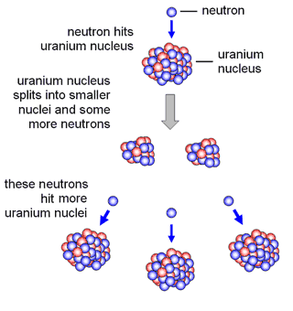

Nuclear fusion
Nuclear fusion involves two atomic nuclei joining to make a large nucleus. Energy is released when this happens.
The Sun and other stars use nuclear fusion to release energy. The sequence of nuclear fusion reactions in a star is complex, but overall hydrogen nuclei join to form helium nuclei. Here is one nuclear fusion reaction that takes place:
Hydrogen-1 nuclei fuse with hydrogen-2 nuclei to make helium-3 nuclei
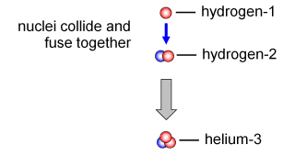
A nuclear fusion reaction showing the nuclei involved

Stars form when enough dust and gas clump together because of gravitational forces. Nuclear reactions release energy to keep the star hot. Planets form when smaller amounts of dust and gas clump together because of gravitational forces.
Stable stars like the Sun change during their lifetime to form other types of stars, such as red giants, white dwarfs, neutron stars and black holes. The fate of a star depends upon how much matter it contains.

Formation of a star
Stars form from massive clouds of dust and gas in space.
Gravity pulls the dust and gas together.
As the gas falls together, it gets hot. A star forms when it is hot enough for nuclear reactions to start. This releases energy, and keeps the star hot.
During its 'main sequence' period of its life cycle, a star is stable because the forces in it are balanced. The outward pressure from the expanding hot gases is balanced by the force of the star’s gravity. Our Sun is at this stable phase in its life.
Gravity pulls smaller amounts of dust and gas together, which form planets in orbit around the star.

Life cycles of stars
A star goes through a life cycle. This is determined by the size of the star. The diagram below summarises the stages you need to know:
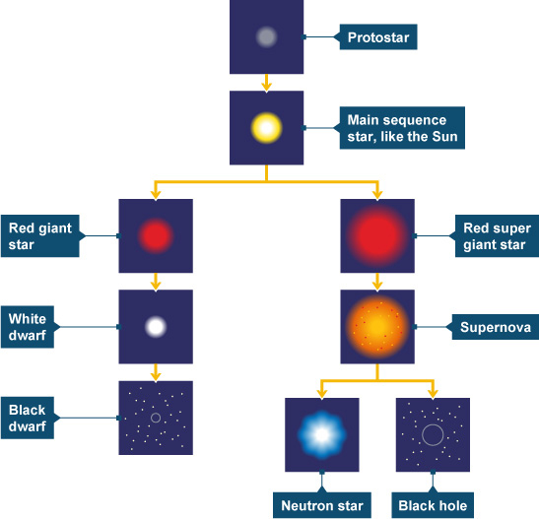

Stars about the same size as our Sun
These follow the left hand path:
Main sequence star → red giant → white dwarf → black dwarf

Stars much bigger than our Sun
These follow the right hand path:
Main sequence star → red super giant → supernova → neutron star or black hole

Fusion in stars

Nuclear fusion
Nuclear fusion involves two atomic nuclei joining to make a large nucleus. Energy is released when this happens.
The Sun and other stars use nuclear fusion to release energy. The sequence of nuclear fusion reactions in a star is complex - but, in general, hydrogen nuclei join to form helium nuclei. Here is one nuclear fusion reaction that takes place:
A nuclear fusion reaction showing the nuclei involved

Fusion in stars
The temperatures and pressures inside a star are so great that nuclear fusion can happen. Stars have enough hydrogen to maintain their energy output for millions of years.
During most of a star's lifetime, hydrogen nuclei fuse together to form helium nuclei. As the star runs out of hydrogen, other fusion reactions take place forming the nuclei of other elements. Heavier elements than hydrogen and helium (up to iron) are formed. Elements heavier than iron are formed in supernovas.
Heavy elements are found in the Sun and planets of the solar system. This suggests that the solar system was formed from the remains of earlier stars that exploded as supernovas.

